LGBTI+ GO Alliance Meeting
Monday 1st February 2021 / 10am-11am

Notes Taken during Meeting

Welcome and Acknowledgement of Country: Michelle Harmer

Attendees: Michelle Harmer (they/them, she/her) Gateway Health, Nicole Robinson (she/her) Advance Practice Leader Family Violence - Orange Door Shepparton, Christine Nunn (she/her) AOD Catchment Planner GV, Joel Board (he/him) A/Team Leader Community Strengthening GSCC, Suzanne Muntz (she/her) La Trobe, Allison Winters (they/them) NHW, Georgina Poort (she/her) Diversity Project, Sarah Ley (she/her) Student Wellbeing Seymour Flexible Learning Centre, Michel Hanson, Chris Parnell (he/him) Interfaith Ministers/Ethnic Council/Emergency Services Chaplin, Laura Powell (she/her) Mitchel Shire YDO *apologies for anyone missed/incorrectly represented

Apologies: Christina Bassani, Katie Clavarino, Damien Stevens-Todd

General Community Updates from attendees
Georgina Poort: Latest initiatives and opportunities for young people below
Please promote:
KALEIDESCOPE PROGRAM – STARTING FEB 9TH
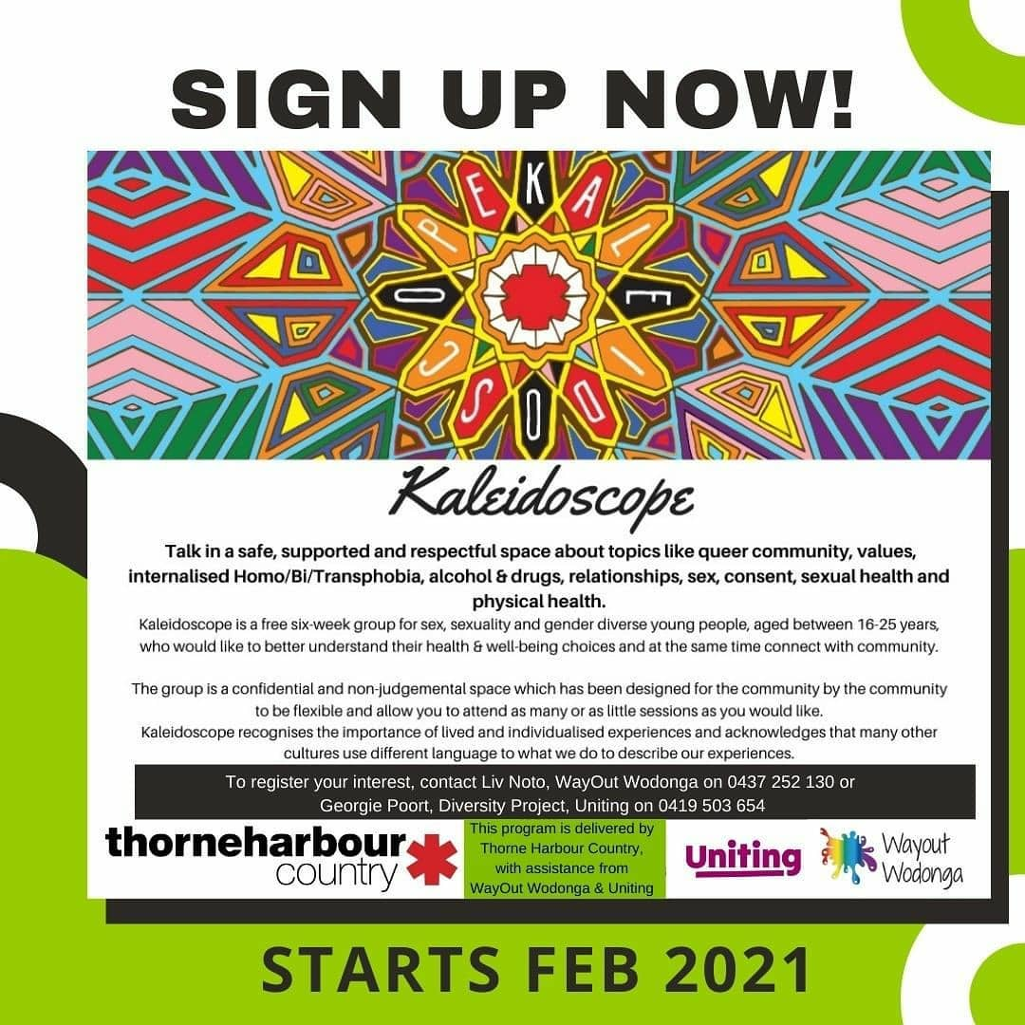
Are you a LGBTIQA+ person aged 16-25?
Want to talk about ALL THE THINGS in a safe and supportive environment?
REGISTER NOW!
Our friends @thorneharbour are excited to bring their online 6 week Kaleidoscope program to the region!
To find out more and register, simply get in touch with:
Wayout Wodonga
E: olivia.noto@gatewayhealth.org.au
P: 0437 252 130
OR
The Diversity Project
E: georgina.poort@vt.uniting.org
P: 0419 503 654

NEPC (NORTH EAST PRIDE COLLECTIVE) – RAINBOW BALL 2021
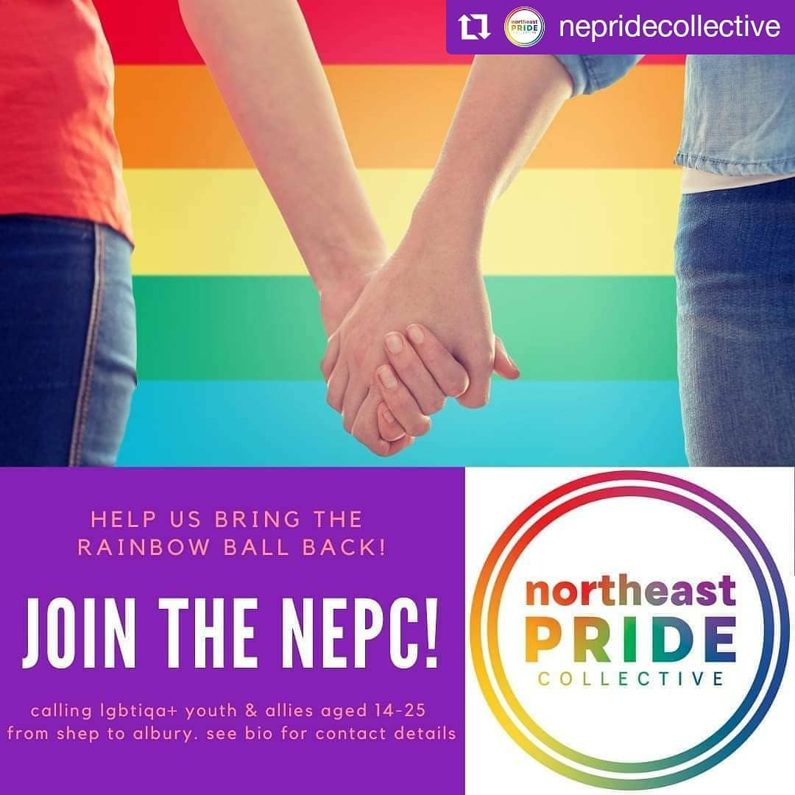
The NEPC is back & looking for young people who are keen to join in, volunteer and bring the next Rainbow Ball to life this year!
If you're a young person under 25 who is keen to be involved, the NEPC would LOVE to hear from you.
DM us or reach out to Georgie or Grace via text, Facebook or email for more information.

REGISTER NOW!
P: 03 5831 6157
M: 0419 503 654
E: georgina.poort@vt.uniting.org
Christine Nunn: Joint alcohol and mental health initiative information and community links, how do we improve access for the LGBTIQA+ Community in relation to AOD/mental health?, looking into work related to informing clinicians and staff within roles to upskill themselves. Further training and links into the community and linking together clinicial and and community-based staff.
“My contact details are: christine.nunn@bigpond.com, 0418 106 199. What is the best way for me to share the GV AOD Services Plan with the group? In relation to the work with the Joint Addiction and Mental Health Goulburn Valley Health Initiative , you can view the program of weekly sessions and information about ECHO projects here: http://www.gvhealth.org.au/jamhecho/ . I will let you know when I get my case study discussed so you can join and see how it works when it is someone without a clinical background presenting and seeking input to the case. In the meantime there maybe some topics that would be of use to you.”

Nicole R: Orange Door, very inclusive space and the MARAM Framework makes sure that LGBTIQA+ communities and families are supported. More to come in the next few month with opening set for March/April.
nicole@primarycareconnect.com.au or 0437 648 920.

Joel Board: GSCC engagement and consultation are big agenda items and community vision:
https://shaping.greatershepparton.com.au/community-vision - run independently to council. Youth department has been re-developed, W&M more strategic focused, working more with community and also with the GSSC councilors. Gender Equity Act commencing 30th March.
Looking to deliver LGBTIQA+ Reference Group – internal council group – mid-Feb. 10-12 people involved – many logistical elements still being developed, perhaps link into the GO Alliance as well in some way. Proposed 60-40% split with working staff in inclusive roles and community as well.
Phone: (03) 5832 9792
Mobile: 0447 063 507
Email: joel.board@shepparton.vic.gov.au

Allison Winters:
LGBTQIA+ Inclusive Practice Conference, FREE, weeklong event... for more information visit:
https://www.northeasthealth.org.au/lgbtqi_conference/

LINE Wangaratta – Queer Arts Program – find out more information here: https://www.facebook.com/linewangaratta

Suzanne Muntz: Lots of things up in the air due to changes at La Trobe, more updates to come as things progress.

Laura Powell: Mitchel Shire – Northern Rural LGBTIQA+ Alliance, forming the Alliance, working with NEXUS to support young people. Also doing community vision as well, similar to GSCC. Forwarding information and education opportunities to local networks and community.
Minus18 rural workshops -
https://www.minus18.org.au/news/minus18-receives-funding-to-host-free-lgbtqia+-education-for-rural-and-regional-schools

Chris Parnell:
Conversion Practice Bill Conversation and overcview. Bill is going to parliament this week and will be voted on in the Upper House.
Other information from Zoom Chat re above:
Watch out everyone, there is a group called Valuing Voices Victoria, that are against the conversion bill. They have worded this as all about protecting families, but you have to really dig between the lines to see their true mission. http://www.valuingvoices.org/?fbclid=IwAR0gcKKm0aIjo2nq88bFLRV5MV_OdradLqjKF43E-0RWk7GmBDy6t90qUPM
The ACL is busy in the background...https://www.starobserver.com.au/news/conversion-practices-bill/200340?fbclid=IwAR1n09pObUZyPHREzNhNa9WumpUlYzehAOVVMzi1EC3cZdopXxmfgLywrTE

Other business?
Next Meeting?

